**Year 12 ATAR Human Biology ATHBY**

**Task 4: Extended Response**

**Name _____________________**

**Answer Key**

Amy was a fit active young female who noticed she was feeling tired all the time and was finding it difficult to carry out her daily activities. When Amy reflected on how she was feeling she realised that it had been occurring for some months. When she visited her doctor, who took some blood tests, Amy was diagnosed with hypothyroidism.

1. The pituitary gland is referred to as the ‘master gland’ of the endocrine system. Describe how Amy’s pituitary gland would have worked with her thyroid gland when Amy was fit and well.

(6 marks)

May use a fully annotated diagram. Any six of:

* Hypothalamus produces TSH RF
* TSH RF travels into ALP via blood vessels
* TSH stimulates the thyroid gland to produce thyroxine(T4) and

tri-iodothyronine (T3)

* Thyroxine is releases from thyroid into the blood stream
* Increase levels of thyroxine negatively feeds back on ALP via hypothalamus
* Negative feedback loop allows ALP and thyroid to maintain thyroxine at level to allow Amy’s healthy life style

1. What are the likely causes of hypothyroidism and what other symptoms might Amy be experiencing? (6 marks)

Causes - Any three of the following

Lack of iodine in the diet / surgery / cancer / Hashimoto’s disease (autoimmune) / radiation

Symptoms - Any three of the following

Decrease heart rate and blood pressure / cold intolerance / weight gain / goitre / fatigue / decrease thyroxine

1. Draw a diagram to explain one way Amy’s thyroid hormone feedback loop has changed since she has had hypothyroidism. Explain what treatment Amy would require to allow her to become symptom free. (8 marks)

Three marks for diagram, one mark for each gland and hormone

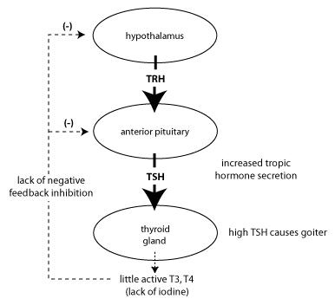

Any three of the following

* Low levels of iodine in diet
* Less T4 & T3 synthesised-T4 for iodine molecules / T3 3 iodine molecules
* Low levels detected by hypothalamus
* TSH RF released by hypothalamus
* Acts on ALP-releases TSH
* TSH acts on thyroid-increases number of follicle cells to attempt to produce more T4 & T3

**Treatment**

* Treatment replace iodine in diet (1 mark)
* Enables thyroid to produce thyroxine -Inhibits hypothalamus/reduces production of TSH RF (1 mark)

**OR**

Hashimoto Thyroiditis

Three marks for diagram one mark for each gland and hormone

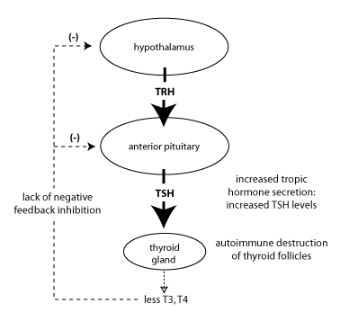

Any three of the following

* autoimmune destruction of the thyroid gland
* antibodies to thyroid antigens, as well as infiltration by cytotoxic T cells, lead to destruction of thyroid tissue
  + Less T4 and T3 synthesised
  + Low levels detected by hypothalamus
  + TSH RF released by hypothalamus
  + Acts on ALP-releases TSH
  + TSH acts on thyroid to produce more T4 & T3 – cells unable to respond

**Treatment (2 marks)**

* replacement therapy with thyroxine (T4)
* T4 must be taken for the rest of patient’s life

**Comments:**